Secure Programming Final Writeup

I chose a project from Computer Programming 1. It takes a file and encrypts/decrypts it.

Some initial problems before editing are:

1. Input Validation
   1. There is not system in place to check if the file is real. If the file is not real it will break.
2. Error Handling-
   1. There is not a system in place if a file can’t be opened. Goes with input validation.
3. File Handling
   1. The file handling is done outside of the functions where it is defined which you usually don’t want to do.
   2. The close functions are also outside the functions and should be in them because it crashes.
4. Better instructions for user
   1. Not great user interface

Test coverage is 0% because there were no tests.

I have adjusted input validation so that it throws an exception if the file is not real or if it is not the correct value for the function. I added errors exceptions what the files have in them so that it makes sure it is decryptable.

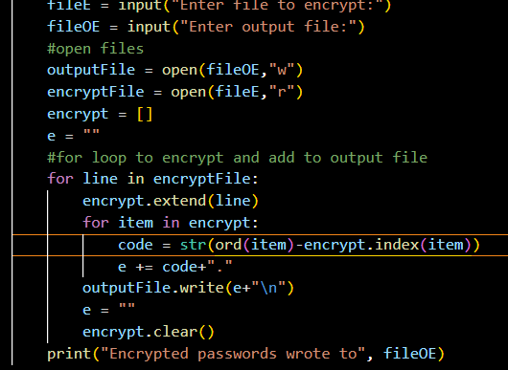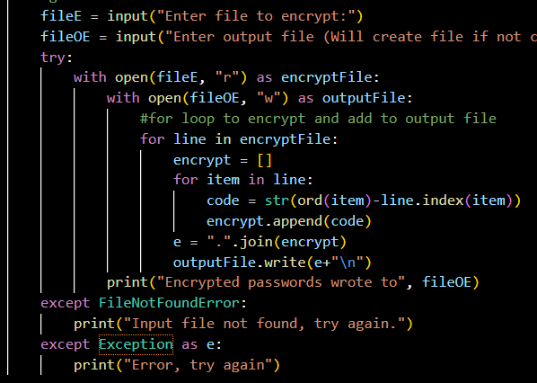

I have added testing coverage. It currently is at 87%, the only part it doesn’t check is the user choice for what they’re going to do.

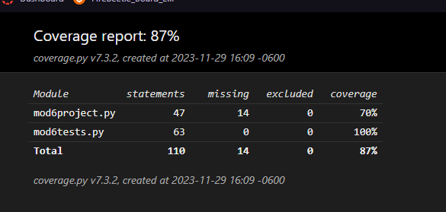

I changed it so that the files are opened with with so that they are closed properly and I don’t need .close().

I added a couple things for user interface and like a line describing what the program does and with the output file.